Task A (Ranking): Write a query to assign a rank to books within each Genre based on their Price (Highest price = Rank 1).

ranked all products in your e-commerce database from most expensive to least expensive using the RANK() window function.
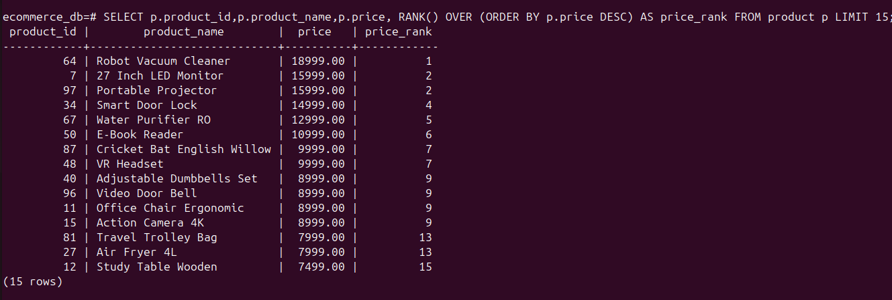

Task B (Running Total): specialized task to calculate the cumulative sum of book prices order by ID.

calculated a running total of product prices, ordered by product ID, using the SUM() window function.
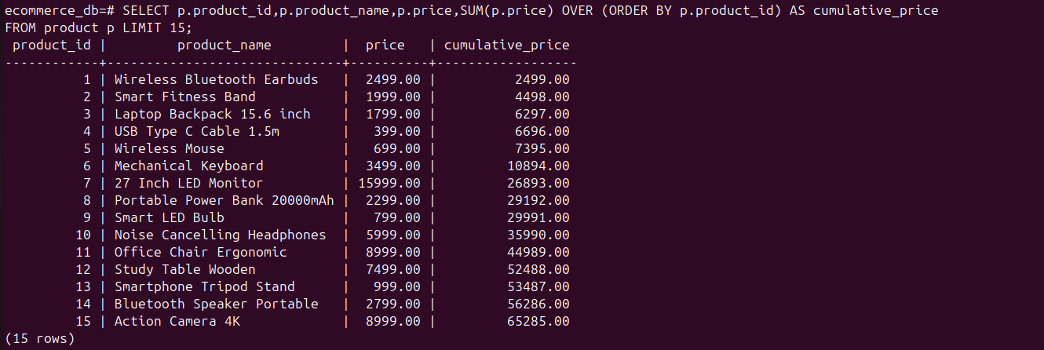

Task C (Lead/Lag): Display each book's price alongside the price of the next most expensive book.

displayed each product’s price along with the price of the next cheaper product, using the LEAD() window function ordered by price in descending order.

